Virtualization Discovery and Inventory Details Custom Views
September 2020
Version 8
Created September 25 2020
Contents
Document history 3
Related documents 3
Goal of the view and approach 4
Goal 4
Preview 4
Virtualization Discovery Details (NR) 4
Virtualization Overview incl. vCenters (NR) 5
Views creation code (FNMS 2016 and later) 5
View code for Virtualization Discovery Details (NR) 5
View code for Virtualization Overview incl. vCenters (NR) 5

Document history
Date | Revision | Description | Author(s)
April 11, 2018 | 1 | Initial revision | Nicolas Rousseau
August 23, 2018 | 4 | Fix on VM status in the Virtualization Overview incl. vCenter view. | Nicolas Rousseau
Sept 2, 2019 | 5 | Added the vCenter name based on IP Address match in the Virtualization Overview incl. vCenter view | Nicolas Rousseau
Apr 21 2020 | 6 | Added vCenter Name based on virtualization management table | Nicolas Rousseau
June 25 2020 | 7 | Renamed columns, converted bytes into GB, changed VM Status | Nicolas Rousseau
September 25 2020 | 8 | Added the hosts and inventoried vms entity information in the View code for Virtualization Overview incl. vCenters (NR) report. | Nicolas Rousseau

Related documents
Document name | Reference

Goal of the view and approach

Goal
The two views described in this document aim providing more visibility into virtualized infrastructures, particularly clusters.
- A first Virtualization Discovery details provides information on Hypervisors (vCenters, HyperV, Oracle VMs hosts, ESX servers) that have been discovered online by the beacons
- A second view deep dives into vCenter inventory: list of vCenters (not visible in FNMS), Clusters, Hosts and Voirtual Machines, including the virtual machines not inventoried by FNMS (that are not visible in FNMS UI).
These views bring the following value:
- The first view points to vCenters that may not yet be set for inventory in Inventory and Discovery rules, or that fail being inventoried (no valid password set on beacons). If you compare the list of active vCenters of view one with the list of inventoried vCenters in view two, you know where you should focus your vCenter inventory efforts
- Second view
  - Gives the list of vCenters and their links to Clusters, hosts and VMs. This can be useful in the context of discussions with Oracle (where Oracle Database are supposed to be licensed at vCenter level for versions of vCenter greater than 5.0)
  - Identifies VMs that are managed by inventoried vCenters but not inventoried by FlexNet Inventory Manager or other inventory tools (and that have no record in the “All Inventory” screen). These VMs are flagged as “Inventoried = Not Inventoried”)

Preview

Virtualization Discovery Details (NR)
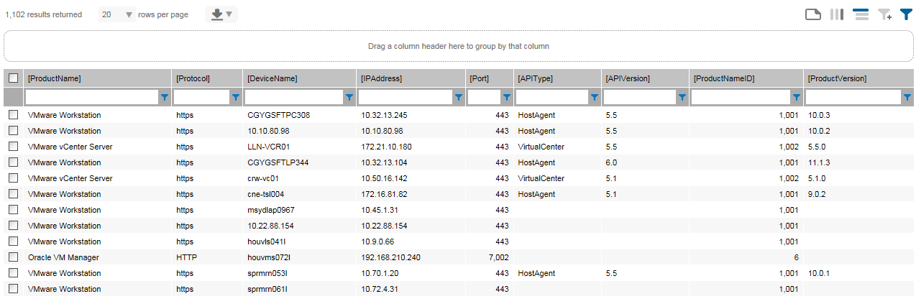

Virtualization Overview incl. vCenters (NR)
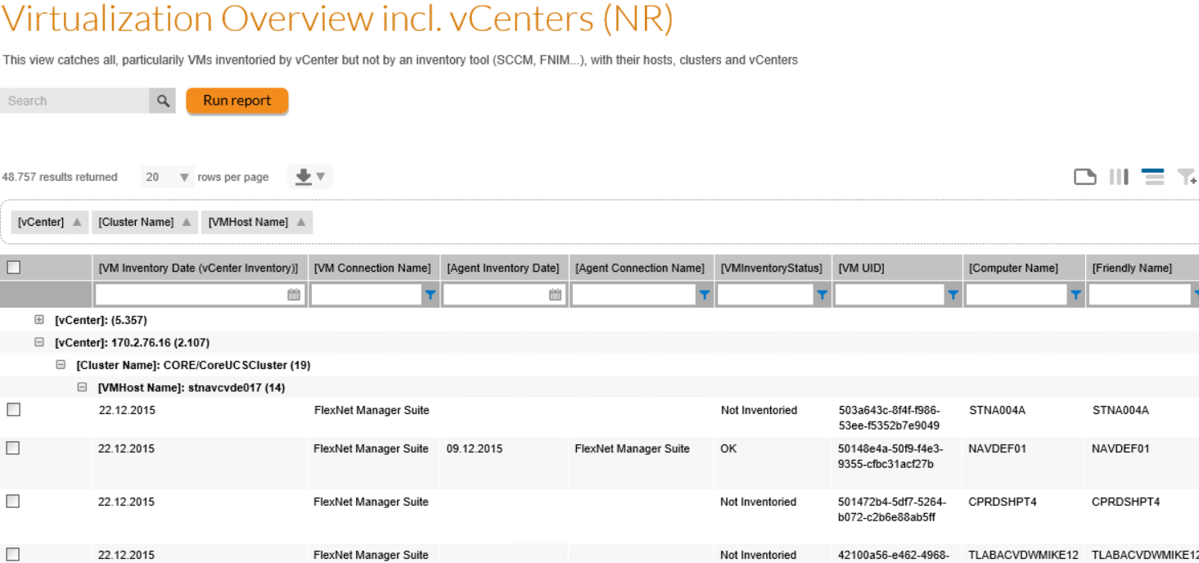

Views creation code (FNMS 2016 and later)
To create the views, please copy and paste the code in the embedded Word Documents below making sure you are on the SAM database of FNMP (often named FNMSCompliance, FNMS or FNMP)

View code for Virtualization Discovery Details (NR)

View code for Virtualization Overview incl. vCenters (NR)
View creation script

Data extraction script

About Flexera
Flexera is reimagining the way software is bought, sold, managed and secured. We view the software industry as a supply chain, and make the business of buying and selling software more transparent, secure, and effective. Our Monetization and Security solutions help software sellers transform their business models, grow recurring revenues and minimize open source risk. Our Vulnerability and Software Asset Management (SAM) solutions strip waste and unpredictability out of buying applications, helping companies purchase only the software and cloud services they need, manage what they have, and reduce license compliance and security risk. In business for 30+ years, our 1000+ employees are passionate about helping our 80,000+ customers generate millions in ROI every year. Visit us at: www.flexera.com

Flexera
300 Park Blvd., Suite 500
Itasca, IL 60143
USA

Itasca (Global Headquarters):
+1 800-374-4353

United Kingdom (Europe, Middle East Headquarters)
+44 370-871-1111
+44 870-873-6300

Japan (Asia, Pacific Headquarters)
+81 3-4360-8291

Australia
+61 3 9895 2000

www.flexera.com

©2018 Flexera. All rights reserved.
All other brand and product names are trademarks, registered trademarks, or service marks of their respective owners.

©2018 Flexera All rights reserved. All other brand and product names are trademarks, registered trademarks, or service marks of their respective owners.

