Oracle Instances details views
August 2022
Version 5
Last Modified August 5th 2022
Contents
Document history 3
Related documents 3
Business need and approach 4
Views preview and code 5
Oracle Options Features Usage Details (NR) 5
Preview 5
View details 5
Creation code 5
Oracle Instances details incl. Exact Version (NR) 6
Preview 6
View details 6
Creation code (FNMS 2016+) 7
Oracle Options Features Details (NR) 7
Preview 7
View Details 7
Implementation 8
All Oracle Applications Accounts (NR) 10
Preview 10
View details 10
Creation code (FNMS 2016+) 10
Oracle Instances Inventory Date From Inventory Manager (NR) 11
Preview 11
View details 11
Creation code (FNMS 2016+) 11
Oracle Instances Options Details (NR) 12
Preview 12
View details 12
Creation code (FNMS 2016+) 12

Document history
Date | Revision | Description | Author(s)
October 18th, 2018 | 1 | Initial version | Nicolas Rousseau
March 26 2019 | 2 | Added the instances features details | Nicolas Rousseau
November 13 2020 | 3 | Template change, added LMS features options flat view. | Nicolas Rousseau
Feb 18th, 2021 | 4 | Added the Options Features Usage Details report (for FNMS 2020R1 and later) | Nicolas Rousseau
March 23rd, 2021 | 5 | Added the Oracle Instances details incl. Exact Version (NR) report | Nicolas Rousseau
Sept. 23, 2021 | 6 | Minor enhancements | Nicolas Rousseau
April 20^{th,} 2022 | 7 | Enhanced the Oracle Options Features Usage Details (NR) report to mix data with transparency with data missing transparency | Nicolas Rousseau
August 2022 | 8 | Fixed an issue the Options.csv PowerShell collection script for the Oracle Option Feature Usage Detail report. | Nicolas Rousseau

Related documents
Document name | Reference

Business need and approach
Oracle instances details are collected by the FlexNet Inventory agent. The agent runs an LMS verified script that collects a large quantity of information that is made available by FlexNet Manager in multiple places… but that is not available a flat way (across servers, across instances):
- Options features inventory details that are stored in the very cryptic and huge “ORCL_OPTIONS.csv” file you can download from the Oracle instances details page (OracleLMSEvidence.zip). Note that the Oracle transparency feature from FNMS 2020R1, allows, instance per instance, to give the “why” of a used instance.
- All Oracle Applications Account (NR). Oracle Users, that are actually a mix of Oracle DB users and Oracle Enterprise Business Suite users in the details of each Named User Plus or Oracle Application User license
- Server Inventory Date, Oracle Inventory Date in the database of Inventory Manager, using the “InventoryReport view”.
- Instance details (exact version, high water mark, creation date, “isUsed” for options instances accessible from the “attribute” column of the Oracle instances
This document gives the steps to create in an on premise FNMS instance 6 views and implement the ORCL_OPTIONS.csv generation and re-import. These views augment the transparency you can get on Oracle data.
The six views are the following
- Oracle Options Features Usage Details (NR). This view is compatible from FNMS 2020R1 onward, that gives a flat view of the feature usages you can find instance per instance when clicking on the “Yes” link in the instance option details (Oracle Transparency)
- Oracle Instances details incl. Exact Version (NR). This view shows the same columns as the Oracle Instances screen, plus the Database exact version and additional columns (cost center, corporate unit… that you can easily extend with more attributes or links.
- Oracle Options Features Details (NR). Oracle features raw usage information (from ORCL_OPTIONS.csv), filtered on DBA_FEATURE_USAGE_STATISTICS and OEM queries. This view can be extended to more queries types.
- All Oracle Applications Accounts (NR). Instance users (Database and EBS)
- Oracle Instances Inventory Date From Inventory Manager (NR). Instance inventory dates details such as last Oracle inventory Date, last Oracle inventory date of the server, last inventory date of the server etc, extracted from the FNM Inventory database
- Oracle Instances Options Details (NR). all details of options and instances (installation date, last used date etc.) extracted from the instances attributes tables (that you can access through the attribute table on an instance detail). This report can have a large number of rows.
The approach of the views is the following:
- They create procedures: nr_XXX in the FNMSCompliance database
- They create the four associated views, in the FNMP.dbo.ComplianceSavedSearch_MT table, that basically launch the stored procedures to display the view.
- All views filter the data on “authorized devices” for the user
The changes can be simply reverted by deleting the stored procedures and the view from FNMP Web.

Views preview and code

Oracle Options Features Usage Details (NR)
This view is for customers in FNMS 2020R1 and later versions
It collects usage from the transparency table and adds instances that have options active (/used) reported by inventory but that have no transparency data. The transparency is either data with the “used” flag or data with a last used date.

Preview
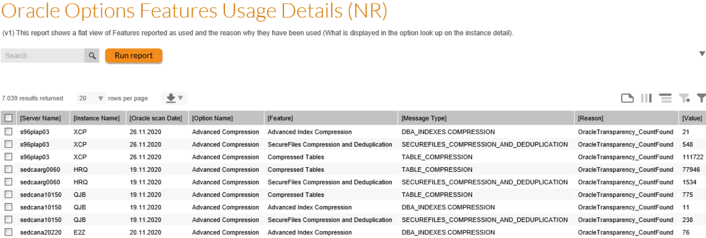

View details
- Server Name
- Instance Name
- Oracle scan Date
- Option Name
- Feature
- Message Type
- Reason
- Value

Creation code

Oracle Instances details incl. Exact Version (NR)

Preview
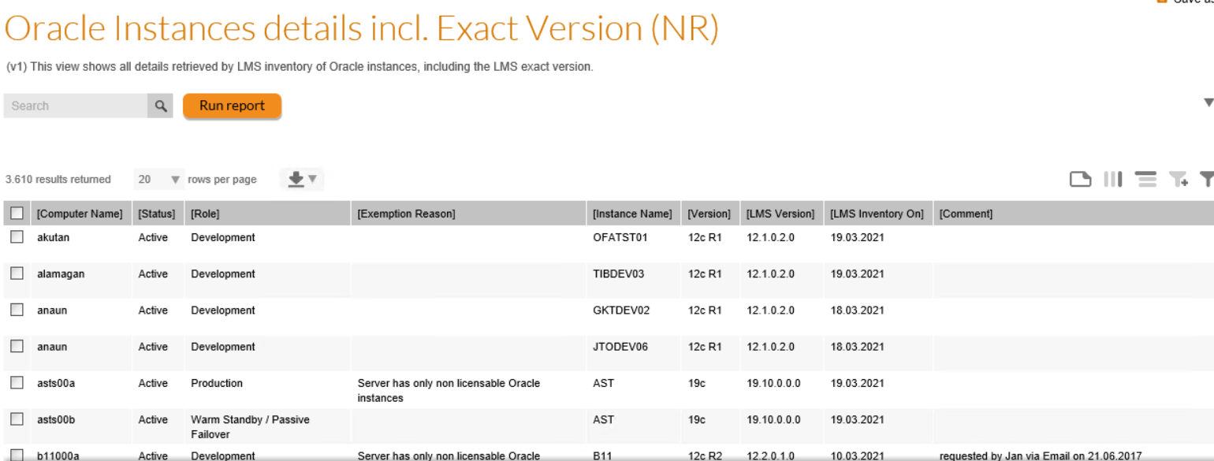

View details
- Computer Name
- Status
- Role
- Exemption Reason
  - If the server of the instance is exempted from the license the instance is consuming from, exemption reason will be displayed
- Instance Name
- Version
- LMS Version
- LMS Inventory On
- Comment
  - This column takes the “installation path” of the instances that can be used to leave a comment
- Application Name
- License Name
  - License that the instance is consuming from
- Managing OEM
- Location
- Corporate Unit
- Cost Center

Creation code (FNMS 2016+)
To create the custom report, run the embedded query in the “FNMSCompliance” or “FNMP” database

Oracle Options Features Details (NR)

Preview

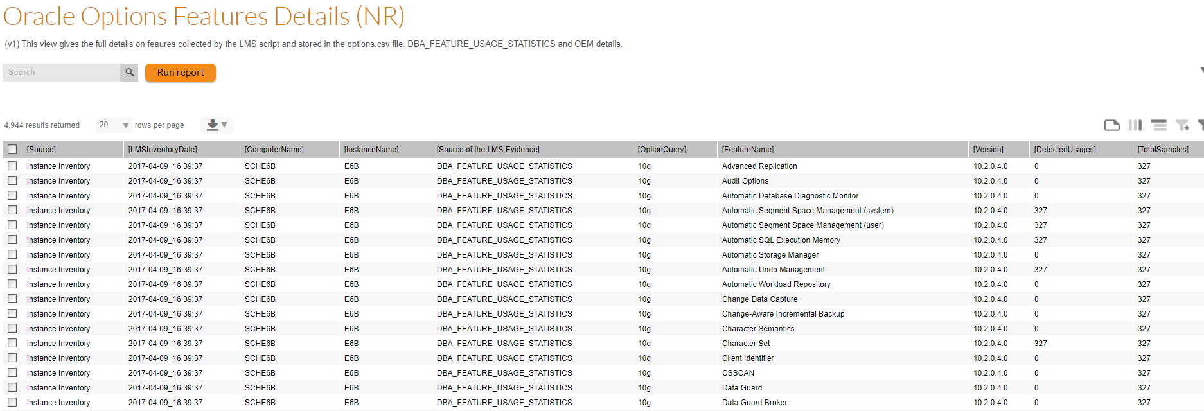

View Details
- Source
- LMSInventoryDate
- ComputerName
- InstanceName
- OptionName
- OptionQuery
- FeatureName
- SQL_ERROR_CODE
- SQL_ERROR_MESSAGE
- Version
- DetectedUsages
- TotalSamples
- PackCurrentlyUsed
- FeatureCurrentlyUsed
- FirstUsageDate
- LastUsageDate
- FirstSampleDate
- LastSampleDate
- SampleInterval
- ExternalOEMSource
- OEMInstance
- RecordType
- LicenseConsumedByTheInstance
- PossibleIssues
- Location

Implementation
If you are on FNMS / ITAM 2020R1 and later and get enough information with the “Oracle Options Features usage details” report, we recommend we don’t use this more complex implementation. A change performed on 2022 August 5th in the PowerShell script fixes and issue that multiple processes where ran (execution policy setting in first line (now commented) was causing the issue).
This view requires a higher implementation effort than the others, as there is a need to generate the Options.csv file and re-import it into FNMS to allow the data to be exported into a reporting table queried by the report. There are 3 stepst in the implementation
- Place the file in a folder (extraction PowerShell script, business adapter that imports the data into a reporting tables, .bat file that will launch sequentially the extraction and the import)
- Schedule the data extraction with a Windows scheduled task
- Create the report (that will query the reporting table fed by the Business Adapter)

Place the implementation files in the appropriate folder
The embedded zip file contains all the files necessary for the data extraction and reimport
- LMSFilesExtraction.ps1
  - This file contains the code
    - To connect to your FNMS Compliance SQL Database (using the user running the scheduled task (use the FlexNet Manager Service user for instance that has rights on the database)
    - To Extract the OracleLMSAuditEvidence.zip file from the Document database
    - To unzip the files in the …/Data folder
  - You need to update this file to match the SQL database details and the folders
- LMSOptioncsvImport.xml
  - This Business Adapter XML file will
    - Read the data in LMS_OPTIONS.csv (also named ORCL_OPTIONS.csv in more recent implementations) and write it in a Physical Table (ECMImport_LMS_Details), created for each new import
    - Insert the data (after transformation) into the reporting table: (nrLMSOptionsDetailsForReport)
  - You need to make sure the file is correctly selected (right file name, right folder)
- RunLMSZipExportAndImportIntoFNMS.bat
  - This .bat file
    - Will need to be ran by a Windows Scheduled task daily after inventory import (noon)
    - Runs the PowerShell file for extraction, then the Business Adapter, and logs the events
  - You need to update in the file the folders to match your implementation

Create a Windows scheduled task that will run the bat script once a day
Details
- Triggers: Noon
- Action: RunLMSZipExportAndImportIntoFNMS.bat
- Use following user account (logged or not): FlexNet Service User

Create the “Oracle Options Feature Details (NR)” report
To create the custom report, run the embedded query in the “FNMSCompliance” or “FNMP” database

All Oracle Applications Accounts (NR)

Preview
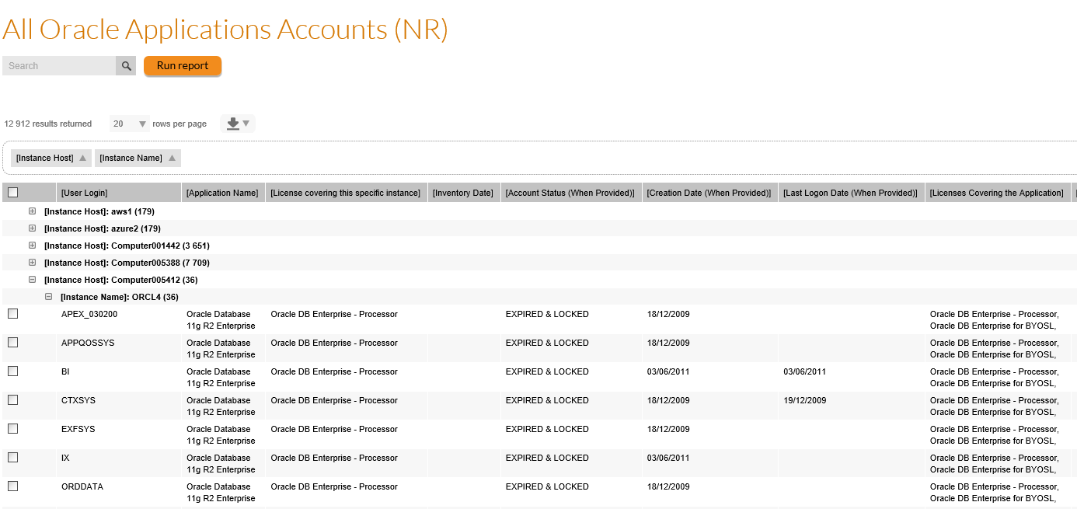

View details
- Covers Database and Enterprise Business Suite
- Server
- Instance
- Account name and status
- License covering the Oracle instance

Creation code (FNMS 2016+)
To create the custom report, run the embedded query in the “FNMSCompliance” or “FNMP” database

Oracle Instances Inventory Date From Inventory Manager (NR)

Preview
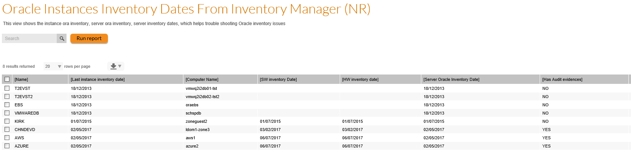

View details
- Instance Name
- Server Name
- SW inventory data for the server
- HW inventory Date
- Server last Oracle Inventory Date
- Instance last Inventory Date
- Has Oracle Audit information (Inventory was performed by the FNMP LMS verified Date)
- Server Location
- Server Cost Center
- Server Corporate Unit

Creation code (FNMS 2016+)
To create the custom report, run the embedded query in the “FNMSCompliance” or “FNMP” database.
You need to make sure in the query that the right database names are used, see comments: !!!Please use the Inventory Manager database name here!!!

Oracle Instances Options Details (NR)

Preview
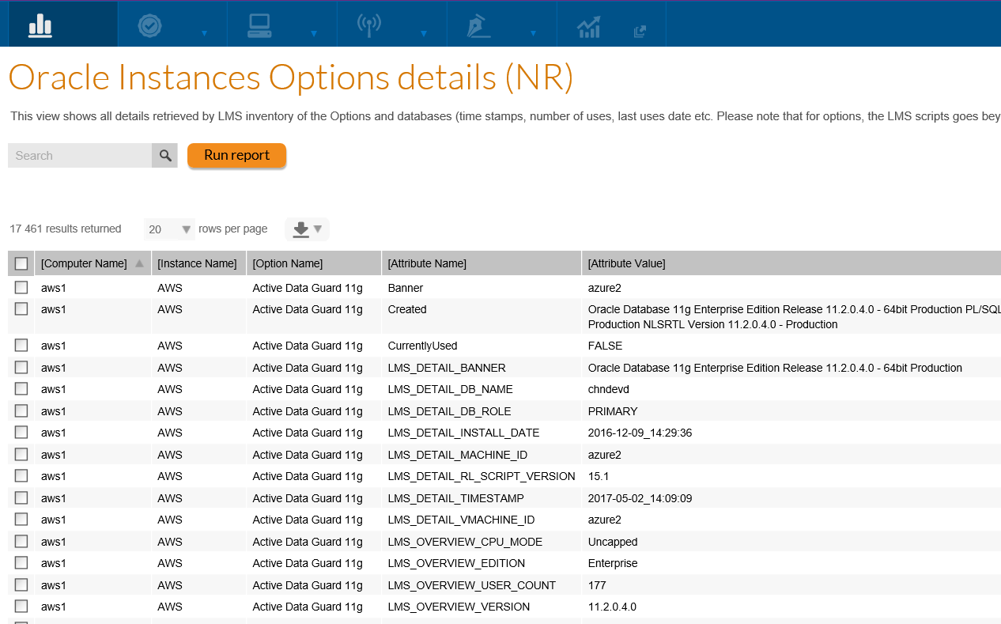

View details
- Computer Name
- Instance Name
- Option Name
- Attribute Name
- Attribute Value
- Server Location
- Server Cost Center
- Server Corporate Unit

Creation code (FNMS 2016+)
To create the custom report, run the embedded query in the “FNMSCompliance” or “FNMP” database

About Flexera
Flexera is reimagining the way software is bought, sold, managed and secured. We view the software industry as a supply chain, and make the business of buying and selling software more transparent, secure, and effective. Our Monetization and Security solutions help software sellers transform their business models, grow recurring revenues and minimize open source risk. Our Vulnerability and Software Asset Management (SAM) solutions strip waste and unpredictability out of buying applications, helping companies purchase only the software and cloud services they need, manage what they have, and reduce license compliance and security risk. In business for 30+ years, our 1000+ employees are passionate about helping our 80,000+ customers generate millions in ROI every year. Visit us at: www.flexera.com

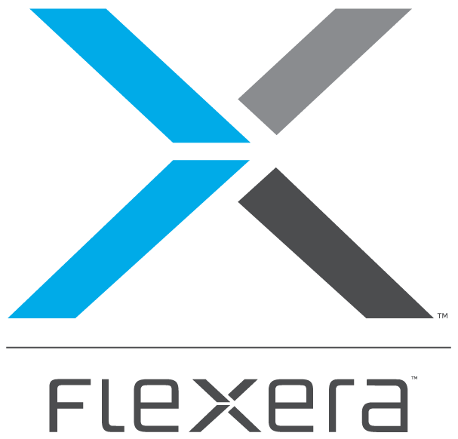
Flexera
300 Park Blvd., Suite 500
Itasca, IL 60143
USA

Itasca (Global Headquarters):
+1 800-374-4353

United Kingdom (Europe, Middle East Headquarters)
+44 370-871-1111
+44 870-873-6300

Japan (Asia, Pacific Headquarters)
+81 3-4360-8291

Australia
+61 3 9895 2000

www.flexera.com

©2018 Flexera. All rights reserved.
All other brand and product names are trademarks, registered trademarks, or service marks of their respective owners.

©2018 Flexera All rights reserved. All other brand and product names are trademarks, registered trademarks, or service marks of their respective owners.

