Allocation Automation Example for FNMS SaaS
April 2018
Version 1
Created April 26, 2018
Contents
Document history 3
Related documents 3
Goal of the view and approach 4
Architecture 5
Implementations steps 5
Pre-requisites: 5
Install needed applications 6
Create and configure the FNMPIntegration database 6
Create a “Computers with no corporate Unit” custom report in the Web UI 7
Import the allocation rules definition into the FNMP database 7
Schedule the Business Adapter import 8
Schedule beacon importer to read the data into SQL database and write into the SaaS instance (Daily, 4:00 PM) 8
Logging: 8

Document history
Date | Revision | Description | Author(s)
April 26, 2018 | 1 | Initial version | Nicolas Rousseau

Related documents
Document name | Reference

Goal of the view and approach
The goal of this solution is to automate the allocation of unallocated devices according to IP address, Domain Name or computer name.
While this solution can apply to an on premise FNMS instances, it brings a solution that opens a large number of applications for FNMS SaaS implementations (Automations, advanced reporting)
FNMS SaaS does not allow direct connection to the SaaS (and multitenant) database for obvious security reasons. The approach to allow advanced scripting is use of a local SQL Express Staging Database on a connected FNMS beacon to run the scripts before uploading the data back to the SaaS instance using a classical beacon integration. The approach is the following:
- A first importer (Excel to SQL database): importIPToCorpUnitMapping.xml
  - Imports the reference data for mapping rules:
    - IP ranges
    - Domain name rules
    - Server Names rules
  - It will be run manually when a allocation rules reference change is performed.
- A second importer (AutomationForDevicesWithNoCorpUnit.xml)
  - Reads in the SaaS db and uploads a “Servers with No Corporate Units” view, using the GetCustomViewResult SOAP API.
  - Loads the data into a local SQL Database
  - Uses the allocation rules reference data imported with another importer to:
    - Allocates corporate unit based on the IP Address, then the Domain of the server, then the name.
    - The logic of the allocation script is sequential
    - No allocation is performed if in the various assessments, more than one country is matched.
      - For instance, if a server has 4 IP Addresses, 4 are matching multiple IP ranges of several countries (entities), and domain or name don’t match to corporate units in a unique country / entity: no allocation will be made (allocation to /TEMP Corporate Unit)
      - If a server has 4 IP Addresses, 4 are matching multiple IP ranges of several countries (entities) but one matches to two IP ranges of two corporate units of the same country, the first corporate unit will be allocated
  - It is scheduled by the Windows task scheduler launching the /XXX/YYY/ZZZ.bat file every day at…
- Finally, a business importer scheduled from the beacon
  - Reads in the SQL db the servers to corporate units allocations (import key is “Device Name” + “IP Address”
  - Updates the SaaS database with the allocations

Architecture
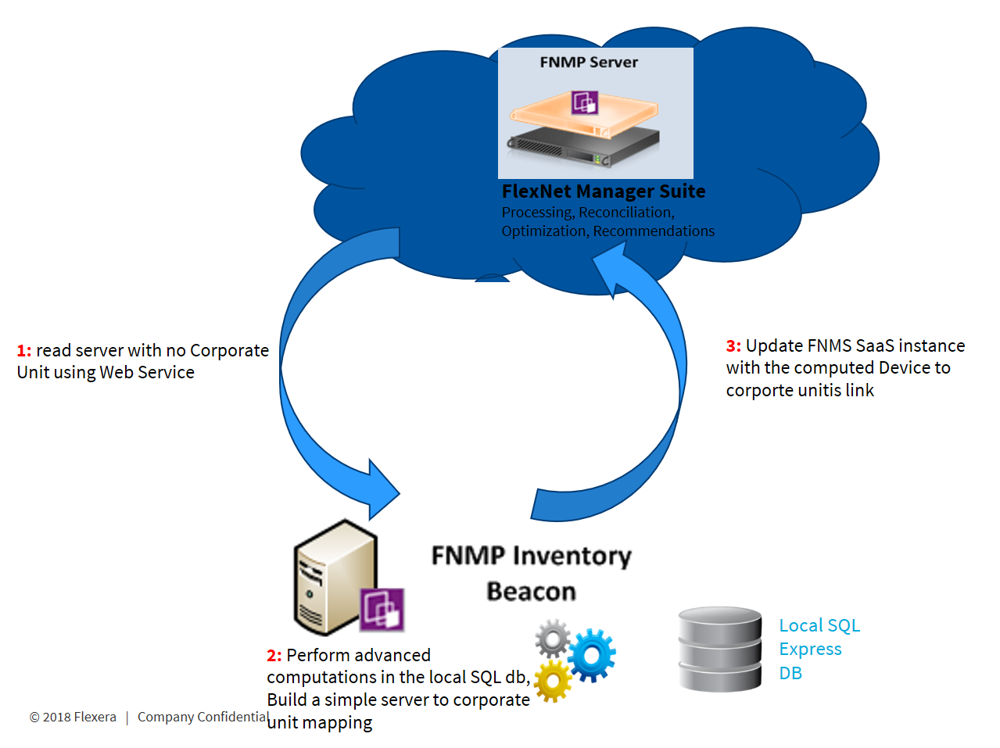

Implementations steps

Pre-requisites:

Enable Web Services on your database (open a ticket)

Create a service user of Web Service type (Service Account, Admin, register the ‘Bearer’ token)
To use the cloud API, you need to generate an access token by going to Accounts > Create a service account, then add a new account with administrator role. A token will be displayed once when you create the account. To use the token in the web service adapter, you will need to add a header to the soap request with name ‘Authorization’ and value ‘Bearer <token>’

Obtain the tenant ID of your database
There’s an API function called GetTenants that returns the tenant UID. If you have access to the customers system, you can also get it from a beacon at HKEY_LOCAL_MACHINE\SOFTWARE\WOW6432Node\ManageSoft Corp\ManageSoft\Common\TenantUID.
Or you can go to Beacons in the FNMS UI and choose Configure Beacon and download a beacon config file which would contain the tenant UID.
This tenant UID will be necessary in the SOAP massage

Install needed applications
- SQL Servers Express (including the SQL Server Management Studio)
- The Business Adaptor Studio be careful to install a 2016 version as the 2017 version has an issue to read in Web Services)

Create and configure the FNMPIntegration database

New database: Name = FNMPIntegration

Create records in the database to mimic an FNMP database:
Create the tables checked for successful Business Adaptor connection

Create function used by the script: IPAddressToInteger
CREATE function [dbo].[IPAddressToInteger](@ip as varchar(15))
returns bigint
as
begin
return (
convert(bigint, parsename(@ip, 1)) +
convert(bigint, parsename(@ip, 2)) * 256 +
convert(bigint, parsename(@ip, 3)) * 65536 +
convert(bigint, parsename(@ip, 4)) * 16777216
)
End

Create a “Computers with no corporate Unit” custom report in the Web UI
With the following columns, capture the view ID (the one in the url when you launch the view)
Computer  ID | Computer  Name | IP  Address | Corporate Structure | Location | Computer Status | Operating  System | Flat Domain | Domain
1670529 | I03195043 | 172.17.195.43 | NULL | NULL | Active | Microsoft Windows Server 2003 Standard Edition | AAAO | AA.es
1670532 | vlp0996 | 172.20.144.37 | NULL | NULL | Active | Microsoft Windows Server 2003 R2 Standard Edition |  | domaine
1670544 | WCL2ADFTEKP2 | 10.235.0.40, 10.235.1.40 | NULL | NULL | Active | Microsoft Windows Server 2016 Standard | IMMOCORP | immoABC
1670570 | w2k8ru0240vg591 | 146.240.224.77 | NULL | NULL | Active | Microsoft Windows Server 2008 R2 Standard | workgroup | workgroup
1670571 | lnxfrh099701731 | 146.242.32.69 | NULL | NULL | Active | RedHatEnterpriseServer | CORPNPT | BBB

Import the allocation rules definition into the FNMP database

Manual, when mapping definitions change.
Open the xml file below with the Business Adapter Studio (version 2016 R1 will be necessary as 2017 has an issue with the Web Service Connection

Select the Excel file below, run (or test) import: the data will be loaded in a ECMImport_IPToCorpUnitMapping table

Schedule the Business Adapter import
This import will read the data into the SaaS instance and write into the SQL database and perform the mapping (Daily, 2:00 PM)

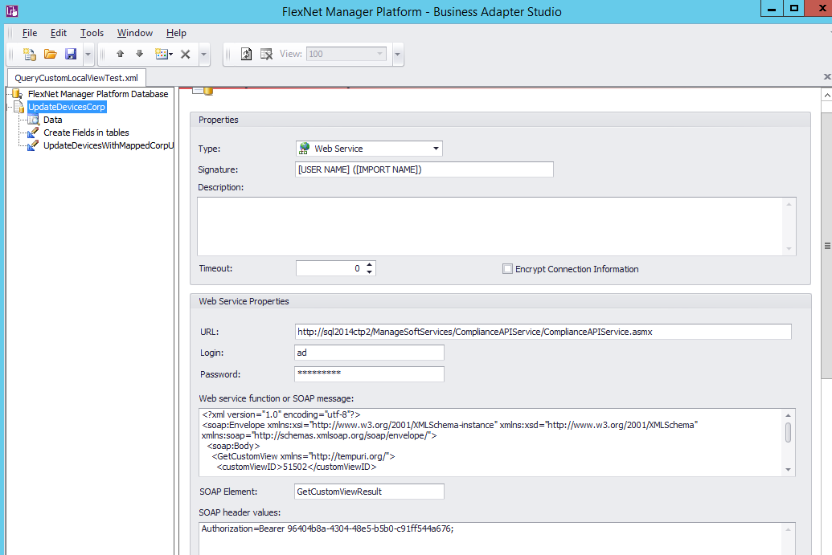

Schedule beacon importer to read the data into SQL database and write into the SaaS instance (Daily, 4:00 PM)

Logging:
The first importer (reading in the SaaS instance) creates “Remarks” in the SQL db that will be mapped to a comments custom property (“Date: Allocated thanks to IP Address XXX.YYY.ZZZ” for instance.
The Beacon logs directly on the Web UI… beacons local logs are on the server at: C:\ProgramData\Flexera Software\Compliance\Logging\BeaconEngine

About Flexera
Flexera is reimagining the way software is bought, sold, managed and secured. We view the software industry as a supply chain, and make the business of buying and selling software more transparent, secure, and effective. Our Monetization and Security solutions help software sellers transform their business models, grow recurring revenues and minimize open source risk. Our Vulnerability and Software Asset Management (SAM) solutions strip waste and unpredictability out of buying applications, helping companies purchase only the software and cloud services they need, manage what they have, and reduce license compliance and security risk. In business for 30+ years, our 1000+ employees are passionate about helping our 80,000+ customers generate millions in ROI every year. Visit us at: www.flexera.com

Flexera
300 Park Blvd., Suite 500
Itasca, IL 60143
USA

Itasca (Global Headquarters):
+1 800-374-4353

United Kingdom (Europe, Middle East Headquarters)
+44 370-871-1111
+44 870-873-6300

Japan (Asia, Pacific Headquarters)
+81 3-4360-8291

Australia
+61 3 9895 2000

www.flexera.com

©2018 Flexera. All rights reserved.
All other brand and product names are trademarks, registered trademarks, or service marks of their respective owners.

©2018 Flexera All rights reserved. All other brand and product names are trademarks, registered trademarks, or service marks of their respective owners.

