Nicolas Rousseau
Senior Product Manager
nrousseau@flexera.com

Version 1
Modified May 25th 2022

Nutanix and RHEV inventory Connectors
May 2022
Contents
Document history 3
Related documents 3
Document Owner 4
Copyright Notice 4
Intellectual Property 4
Restricted Rights Legend 4
Goal of the document and audience 5
Prerequisites 5
Detailed code and steps 6

Document history
Date | Revision | Description | Author(s)
May 25th 2022 | 1 | First version | Nicolas Rousseau

Related documents
Document name | Reference

Document Owner
This document is owned by Flexera Software. Revisions may only be made by Flexera Software.

Copyright Notice
Copyright © 2019 Flexera Software LLC. All Rights Reserved.

This product contains proprietary and confidential technology, information and creative works owned by Flexera Software LLC and its licensors, if any. Any use, copying, publication, distribution, display, modification, or transmission of such technology in whole or in part in any form or by any means without the prior express written permission of Flexera Software LLC is strictly prohibited. Except where expressly provided by Flexera Software LLC in writing, possession of this technology shall not be construed to confer any license or rights under any Flexera Software LLC intellectual property rights, whether by estoppel, implication, or otherwise.

All copies of the technology and related information, if allowed by Flexera Software LLC, must display this notice of copyright and ownership in full.

Intellectual Property
For a list of trademarks and patents that are owned by Flexera Software, see http://www.flexerasoftware.com/intellectual-property. All other brand and product names mentioned in Flexera Software products, product documentation, and marketing materials are the trademarks and registered trademarks of their respective owners.

Restricted Rights Legend
The Software is commercial computer software. If the user or licensee of the Software is an agency, department, or other entity of the United States Government, the use, duplication, reproduction, release, modification, disclosure, or transfer of the Software, or any related documentation of any kind, including technical data and manuals, is restricted by a license agreement or by the terms of this Agreement in accordance with Federal Acquisition Regulation 12.212 for civilian purposes and Defense Federal Acquisition Regulation Supplement 227.7202 for military purposes. The Software was developed fully at private expense. All other use is prohibited.

Goal of the document and audience

This document gives the details for collecting data from Nutanix or Red Hat RHEV cluster and integrating the data into FNMS / Flexera One ITAM
- Create or update clusters
- Create or update Hosts
- Link VMs to Hosts and Host to clusters
The integration also creates Virtual Machines that would not be inventoried but assumes the full inventory is coming from an inventory tool (FNMS agent, SCCM) that include applications inventory. This creation is native in the Spreadsheet adapter design, you can choose to ignore the VMs that have no detailed inventory…

The approach is to read the data in the Cluster Management source (Nutanix Prims / Cluster REST APIs or RHEV mySQL database) and generate the files (Cluster.csv, Compuiter.csv, used as a pivot format) that will be located in the folder that a specific Inventory Spreadsheet Adapter, created from the Beacon UI will read.
The solution work on both on premise and cloud instances.

The spreadsheet adapter expects each column of the templates to exist in the file that will be consumed, but does not require all files of the templates (file evidence, installer evidences etc.) to be present. This, the two integrations below provide the minimum number of files (computers and clusters) but all the columns (very often empty) in the spreadsheet. Note that these are the 2021R1 templates and that an implementation in a future version of FNMS may require to re-align the queries selections with the current template.

To be noted the ComputerID or HostComputerID can be stings in ImportedComputer. The UUID for the sources have been used in these two integrations, in the absence on database ID (integer or bingint).

The read operation will be typically scheduled (from the Windows Scheduler) once a day at 3:00 PM, the Beacon Spreadsheet adapter will be scheduled at 5:00 PM (before the Inventory import and reconcile task that runs once a day typically at 10:00 PM or 00:00.

Prerequisites
There are prerequisites that need to be applied in the two integrations
- The read operations require the right levels of credentials in the source applications (MySQL db or Nutanix Prism / Nutanix clusters).
- For Nutanix, the user running the PowerShell must have the rights to query the Prism AND the clusters.
- The ports between the beacons that will host the PowerShell script and the Spreadsheet inventory adapter and the data sources need to be opened
There are ways to encrypt password in PowerShell, please refer to a PowerShell expert to do this.

Detailed code and steps
- Each reader will need to be executed from a PowerShell (RHEV to be finalized), in the context of a user with the rights on the data sources
  - Nutanix PowerShell Sample
  - SQL Query For RHEV (PowerShell to be finalized)
- The output computer.csv and cluster.csv files are specified in the PowerShell scripts: for instance: C:/Flexera/Integrations/Nutanix/Data
- You need to create a Spreadsheet Adapter for each integration on the Beacon UI
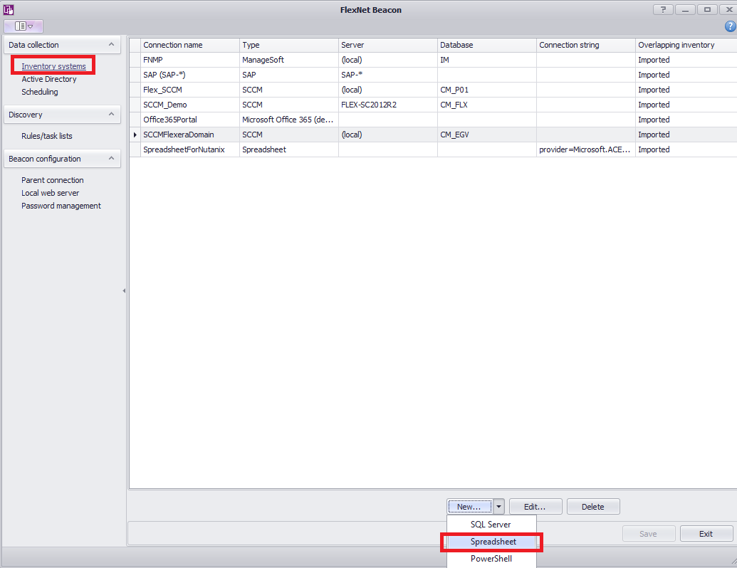
  - Format: csv coma separated with headers. Make sure the Connection folder is the output file folder for the PowerShell script.
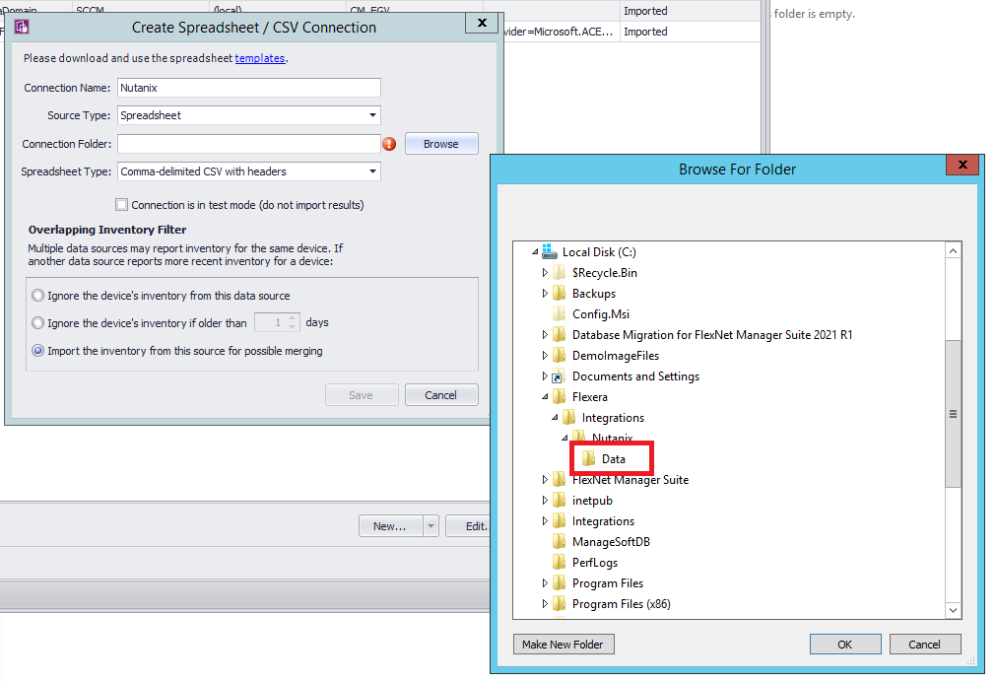
  - Schedule the PowerShell scripts (Daily if you want to have refreshed movements of VMs in Hosts (can be useful for the 90 peak in Windows Server License consumption) with the Windows Task scheduler
  - Schedule the Beacon Spreadsheet adapters with the Beacon scheduler

About Flexera
Flexera is reimagining the way software is bought, sold, managed and secured. We view the software industry as a supply chain, and make the business of buying and selling software more transparent, secure, and effective. Our Monetization and Security solutions help software sellers transform their business models, grow recurring revenues and minimize open source risk. Our Vulnerability and Software Asset Management (SAM) solutions strip waste and unpredictability out of buying applications, helping companies purchase only the software and cloud services they need, manage what they have, and reduce license compliance and security risk. In business for 30+ years, our 1000+ employees are passionate about helping our 80,000+ customers generate millions in ROI every year. Visit us at: www.flexera.com

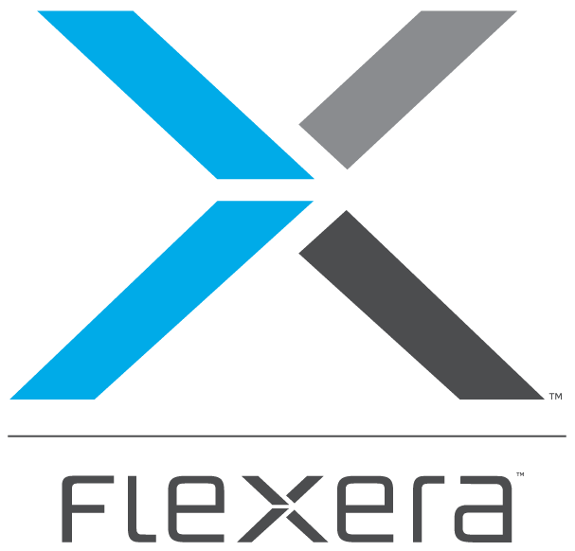
Flexera
300 Park Blvd., Suite 500
Itasca, IL 60143
USA

Itasca (Global Headquarters):
+1 800-374-4353

United Kingdom (Europe, Middle East Headquarters)
+44 370-871-1111
+44 870-873-6300

Japan (Asia, Pacific Headquarters)
+81 3-4360-8291

Australia
+61 3 9895 2000

www.flexera.com

©2018 Flexera. All rights reserved.
All other brand and product names are trademarks, registered trademarks, or service marks of their respective owners.

©2018 Flexera All rights reserved. All other brand and product names are trademarks, registered trademarks, or service marks of their respective owners.

