vCenter Inventory Troubleshooting Custom Report
April 8th, 2022
Version 8
Created September 25 2020
Contents
Document history 3
Related documents 3
Goal of the view and approach 4
Goal 4
Preview 4
Virtualization Overview incl. vCenters (NR) 4
Views creation code (FNMS 2016 and later) 4
View code for Virtualization Overview incl. vCenters (NR) 5

Document history
Date | Revision | Description | Author(s)
April 8, 2022 | 1 | Initial revision | Nicolas Rousseau

Related documents
Document name | Reference

Goal of the view and approach

Goal
Collecting correctly vCenter inventory is critical as the most expensive server licenses require the knowledge of the host / VMs links.
The “All Discovered Devices” screen contains valuable information (VMWare inventory date, VMWare discovery date etc.), but analyzing the data may be complex because the logs must be accessed one by one on the “status” tab of the discovered devices, and data such as virtualization product and versions are not available a screen column.
It collects the following information
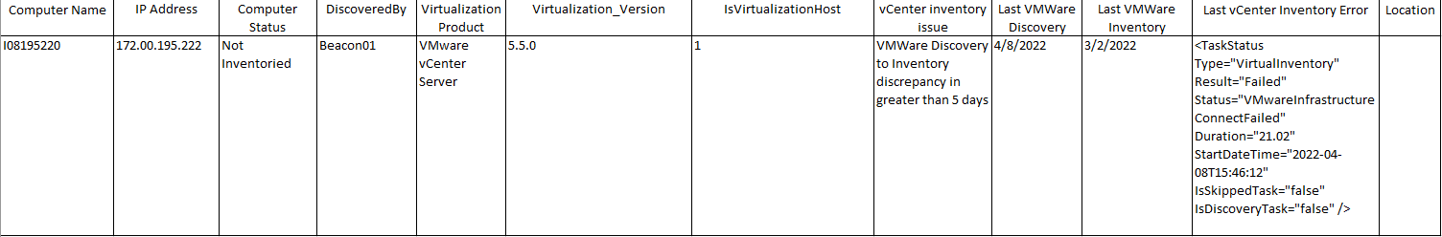

Preview

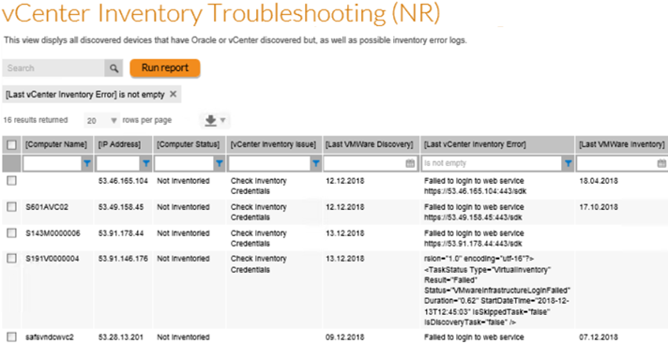

Views creation code (FNMS 2016 and later)
To create the views, please copy and paste the code in the embedded Word Documents below making sure you are on the SAM database of FNMP (often named FNMSCompliance, FNMS or FNMP)

About Flexera
Flexera is reimagining the way software is bought, sold, managed and secured. We view the software industry as a supply chain, and make the business of buying and selling software more transparent, secure, and effective. Our Monetization and Security solutions help software sellers transform their business models, grow recurring revenues and minimize open source risk. Our Vulnerability and Software Asset Management (SAM) solutions strip waste and unpredictability out of buying applications, helping companies purchase only the software and cloud services they need, manage what they have, and reduce license compliance and security risk. In business for 30+ years, our 1000+ employees are passionate about helping our 80,000+ customers generate millions in ROI every year. Visit us at: www.flexera.com

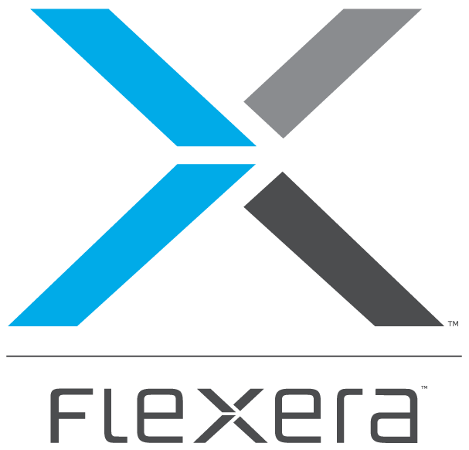
Flexera
300 Park Blvd., Suite 500
Itasca, IL 60143
USA

Itasca (Global Headquarters):
+1 800-374-4353

United Kingdom (Europe, Middle East Headquarters)
+44 370-871-1111
+44 870-873-6300

Japan (Asia, Pacific Headquarters)
+81 3-4360-8291

Australia
+61 3 9895 2000

www.flexera.com

©2018 Flexera. All rights reserved.
All other brand and product names are trademarks, registered trademarks, or service marks of their respective owners.

©2018 Flexera All rights reserved. All other brand and product names are trademarks, registered trademarks, or service marks of their respective owners.

