Oracle License Consumptions and Optimizations Custom Reports
March 2021
Version 44
Created March 12 2021
Contents
Document history 3
Related documents 4
Business Need 5
Goal of the views and approach 5
General concept on custom SQL reports 5
Cluster Level soft partitioning 6
Oracle Licenses Consumptions and Optimizations (NR) 6
Oracle License Optimization Summary (NR) 7
Oracle Options Virtualization Target Architecture (NR) 8
vCenter Level Reporting 9
Oracle Cso and Optim Details at vCenter Level (NR) 9
All vCenters Level Reporting 10
Views creation code (FNMS 2016 and later) 12
Cluster level 12
Oracle Licenses Consumptions and Optimizations (NR) 12
Oracle Licenses Optimizations Summary (NR) 12
Oracle Options Virtualization Target Architecture (NR) 12
vCenter level 12
Oracle Cso and Optim Details at vCenter Level (NR) 12
Oracle Licenses Consumptions at vCenter Level (NR) 12
All levels 12
Oracle Cso and Optim Details at Host, Cluster, vCenter, All vCenters Level (NR) 13
Oracle Licenses Consumptions Summary at Host, Cluster, vCenter, All vCenters Level (NR) 13
Appendix 1: list of columns in the detailed consumption report 13

Document history
Date | Revision | Description | Author(s)
April 11, 2018 | 28 | A number of enhancements since version 1 in 2014 | Nicolas Rousseau
Feb 22 2019 | 33 | Added JRE – JSE installations Report | Nicolas Rousseau
March 10 2020 | 34 | Fixed issue on optimization summary with same product showing in multiple columns in the pivot. | Nicolas Rousseau
March 20, 2020 | 35 | Changed rolled down consumption to float | Nicolas Rousseau
May 26, 2020 | 36 | Enhanced the Oracle Optimization Summary report (rewrite) | Nicolas Rousseau
June 24, 2020 | 37 | Fixed issue on Target Architecture report (sometimes wrong count for recommendedclusterNumberOfCores) | Nicolas Rousseau
July 31 2020 | 38 | Performance enhancement on Oracle Consumption details and optimization report, financial analysis on vCenter level soft partitioning versus Cluster level soft partitioning additional cost. | Nicolas Rousseau
Sept. 21 2020 | 39 | Performance enhancements. Added the Corporate Unit in report. Created the “Cluster, vCenter, all vCenters and Host’ hard partitioning reports | Nicolas Rousseau
Nov 19 2020 | 41 | Fix of an issue that was breaking the “hierarchical name” | Nicolas Rousseau
Nov 27 2020 | 42 | Fixed issue in all level reports (ClusterLevel was not including non ESX consumptions) + changed the summary report logic | Nicolas Rousseau
Feb 22 2021 | 43 | Fixed issue on host consumption (the number of cores of the host is used, no sub capacity) | Nicolas Rousseau
March 12 2021 | 44 | Added the cluster or host optimizations as a flat version | Nicolas Rousseau

Related documents
Document name | Reference

Business Need
“Am I compliant on Oracle products?” is the very first one of a long series of questions that are worth asking for this expensive and complex Publisher
- Am I using my VMWare virtualization an optimal way given the tough Oracle Licensing?
- If I was counting soft partitioning up to the vCenter, how much cost would it be? What is my risk if Oracle demands it one day?
- Are my Oracle options consistently deployed across clusters? What would be my optimized target architecture?
- How is my Oracle inventory going, do I have issues or patterns that I could identify to make my inventory quality better?
These million dollars questions are hard to answer and require complex deep dive in data crunching and analysis…
The reports below provide a straightforward answer to these questions, mixing better visibility on license consumptions, sharp financial analysis on possibility to optimize the virtualized architecture or inventory data quality

Goal of the views and approach

General concept on custom SQL reports
Each of the views below can be created with the scripts embedded in the Views creation code (FNMS 2016 and later) section. The high-level approach is to create a stored procedure (prefixed with “nr_” to avoid any conflict with out of the box stored procedures. This stored procedure will select Data, make calculations, eventually use temporary tables (dropped at the end of the query)… and finally, make a final SELECT statement that will return the result of the report.
The custom SQL report creation script also created a view, thanks to the ComplianceCustomViewRegister stored procedure. This view has a name, a description, and a SQL execution fields… the report will run the stored procedure.
To revert the changes caused by the reports’ creation, simply delete the stored procedures and the view from the FNMP Web UI. Note that these reports cannot be edited in the Web UI.
Given the number of columns in the reports, you may need to reset the view after launching it
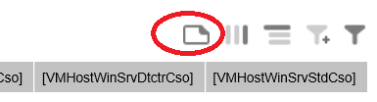
The view is vendor specific for Oracle by changing the filter at the first section (that starts from installed applications level. The filter is currently:
“WHERE licpub.VendorName = 'Oracle'”
The reports can be simplified by choosing the appropriate columns in the final SELECT statement,
commenting, removing etc.

Cluster Level soft partitioning

Oracle Licenses Consumptions and Optimizations (NR)

Description
The view contains the following:
- The hierarchical structure of consumption, servers by server, license by license, like displayed in the consumption tab of the licenses’ details, adding the vCenter level. (vCenter/Cluster/VM Host/VM). The “Click on the column to re-establish hierarchies” column allows to reset the report’s hierarchy
- The list of covered oracle instances
- The list of covered applications (practical when multiple versions or edition of Oracle (or SQL server) are installed
- A license cost per server in Licenses as well as a Waste/ Optimization column that compares the number of Cores of the VM Hosts that have to be licensed a consumption to the sum of installed VMs Cores on ESX hosts
- Everything to tell the story: number of cores, processors, core factor, licensable cores (or processors), version of the vCenter…
The list of columns is provided in appendix 1.

Preview
Server consumptions are displayed in a hierarchical way, optimizations are suggested (here, better use of VMWare virtualization)
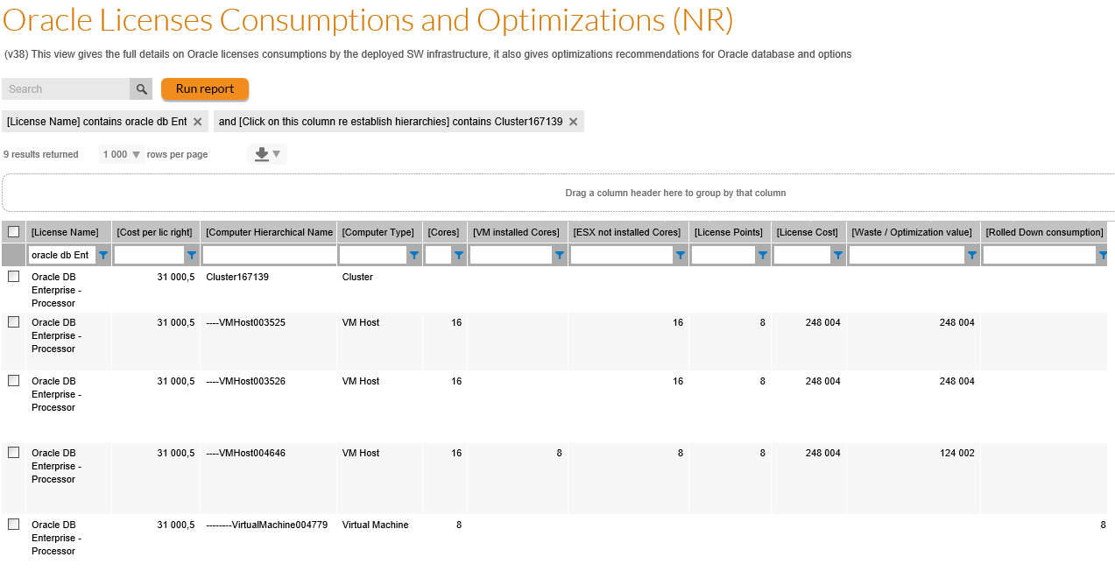
Installed applications covered by the license and Oracle instances are reported

Oracle License Optimization Summary (NR)

Description
This view pivots all wastes or optimizations values at ESX “root node” level, that can be the Cluster or VM Host level depending on installed architectures.

Preview

Pivoted view
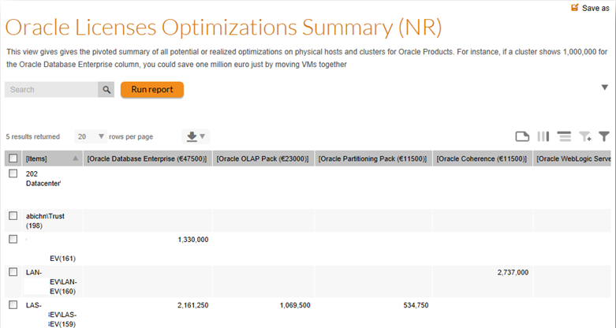

Flat View
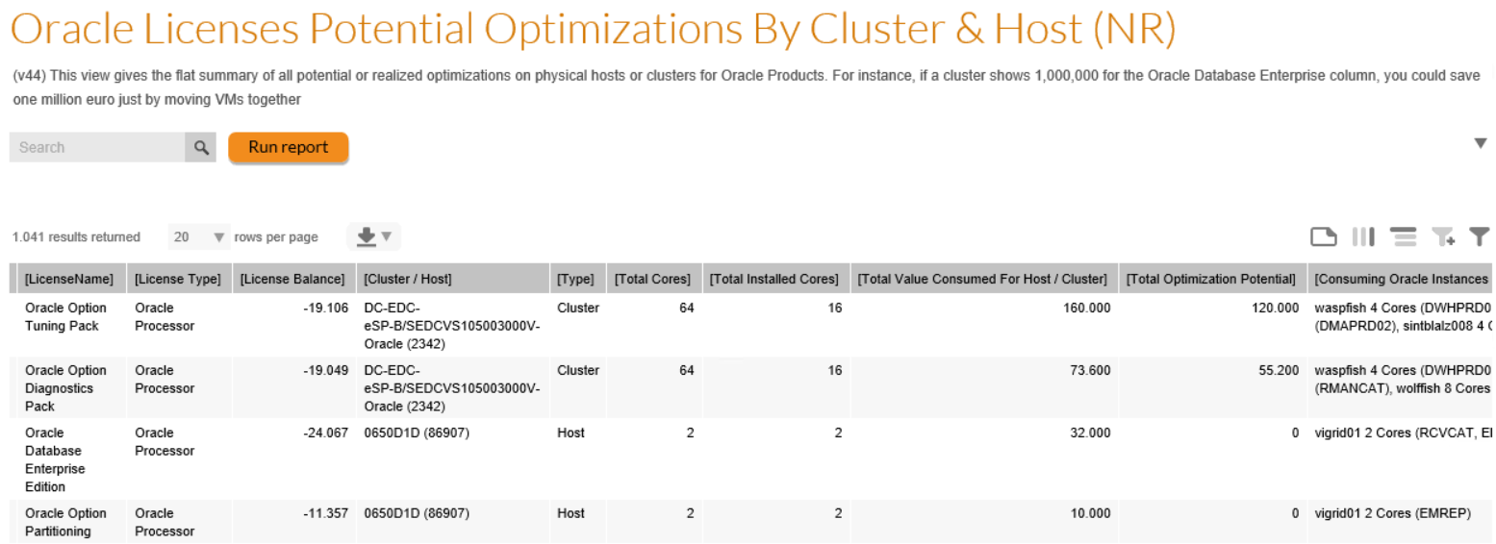

Oracle Options Virtualization Target Architecture (NR)

Description
This view will identify all installed and used options on VMs (where we have the host / cluster information) and will suggest a target virtualization architecture, consisting in gathering all VMs with coherent installed AND used options (for instance, all VMs installed with Tuning Packs, Diagnostic Pack and Advanced Compression) on the same cluster, with a number of cores corresponding to the sum of number of cores of installed VMs.
If your company is not in a ULA (or has deployed Options not in a ULA), the savings are counted in USD millions.
This recommendation applies for VMWare 5.0 version where soft partitioning is applied at cluster level.

Preview
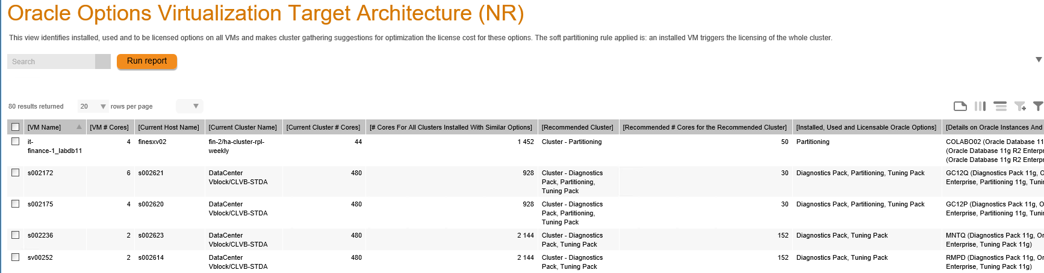

vCenter Level Reporting

Oracle Cso and Optim Details at vCenter Level (NR)

Description
This view has the same logic as the Oracle Server Consumptions and Optimization (NR) one, and provides the vCenter soft partitioning rules…
It shows consumptions for all ESX servers that belong to clusters outside of the installed applications measured in Oracle Processor metric, but in the same vCenter.
This report shows
- The Cluster level soft partitioning consumptions
- The vCenter level additional consumptions (The ESX that would not consume in the cluster soft partitioning are flagged with IsAddedForvCenterLevelConsumption = Yes)
- The total consumption that is the sum of both
- The total additional cost of licensing at vCenter level instead of Cluster level (the “Cost of vCenter Rule For License” column)
- The “Click on the column to re-establish hierarchies” column allows to reset the report’s hierarchy

Preview
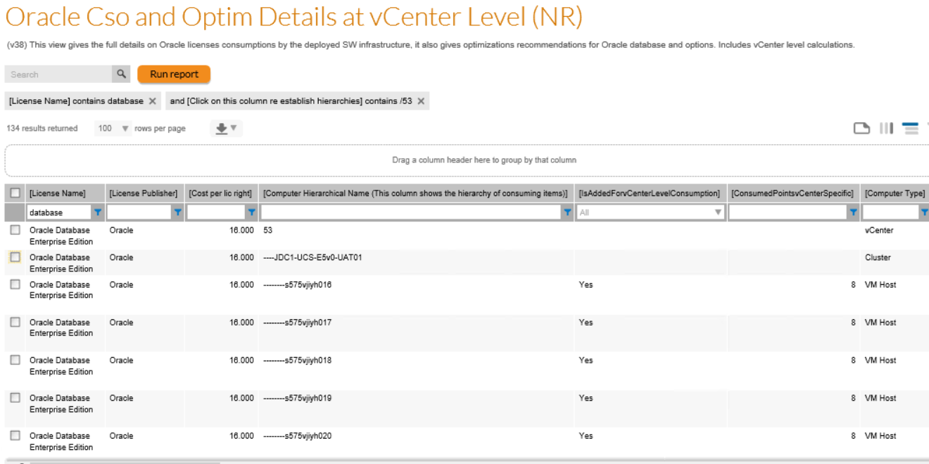
Oracle Licenses Consumptions at vCenter Level (NR)

Description
This report shows the flat list of Oracle licenses, with
- Purchases
- Consumptions (considering cluster level soft partitioning)
- The additional consumptions due to vCenter soft partitioning licensing
- The total consumptions
- The financial impact of vCenter soft partitioning versus Cluster

Preview
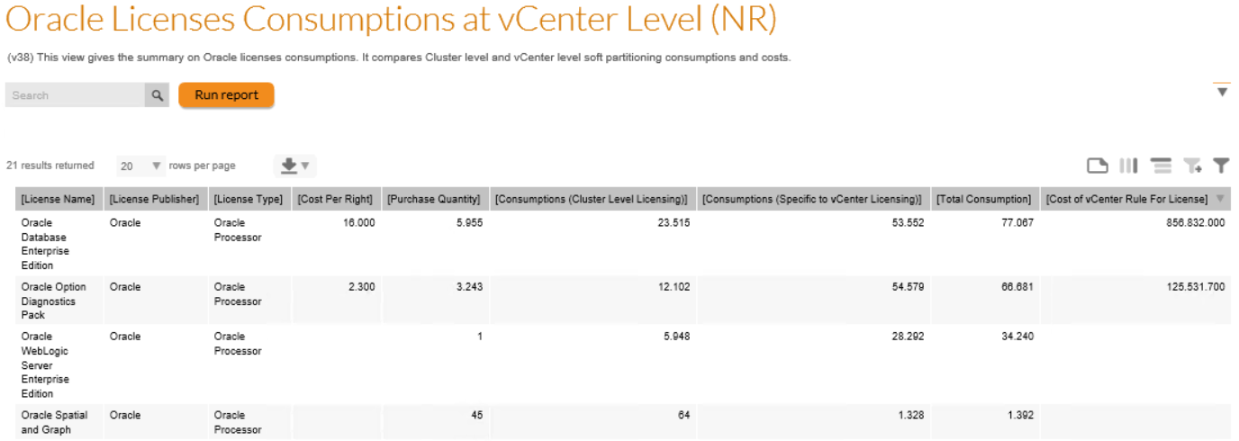

All vCenters Level Reporting
Oracle Licenses Consumption Summary at all Levels (NR)
The reports summarizes for each Oracle Processor license (Database and Options) what are the consumptions for each option
- FNMS current counts (License VMWare VMs at Cluster level, apply hard partitioning for LPARs, Solaris Zones…)
- Apply the same FNMS counts, except: VMs trigger vCenter consumption (vCenter level partitioning)
- Apply the same FNMS counts, except: VMs trigger vCenter consumption (vCenter level partitioning)
- Apply the same FNMS counts, except: VMs trigger host only consumptions for all their cores ((Theoretical) ESX hard partitioning)
The report compares:
- Additional cost for vCenter level versus Cluster level consumption (vCenter 5.1+ rule).
- Additional cost for all vCenter level versus Cluster level consumption (vCenter 6.0+ rule)
- Saving of ESX hard partitioning versus Cluster soft partitioning.

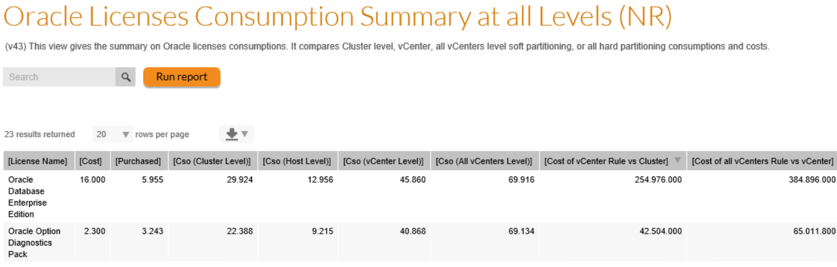
Oracle Licenses Detailed Consumptions at all Levels (NR)
This report shows all the details of the consuming nodes and show as columns the “vCenter rule specific” consumptions (when an ESX server is in a Cluster that has no installed VM but has a VM on another cluster of the vCenter installed with the consuming application), “All vCenters rule specific” consumptions (when an ESX server is in a vCenter that has no installed VM at least one VM in the entire estate is installed)
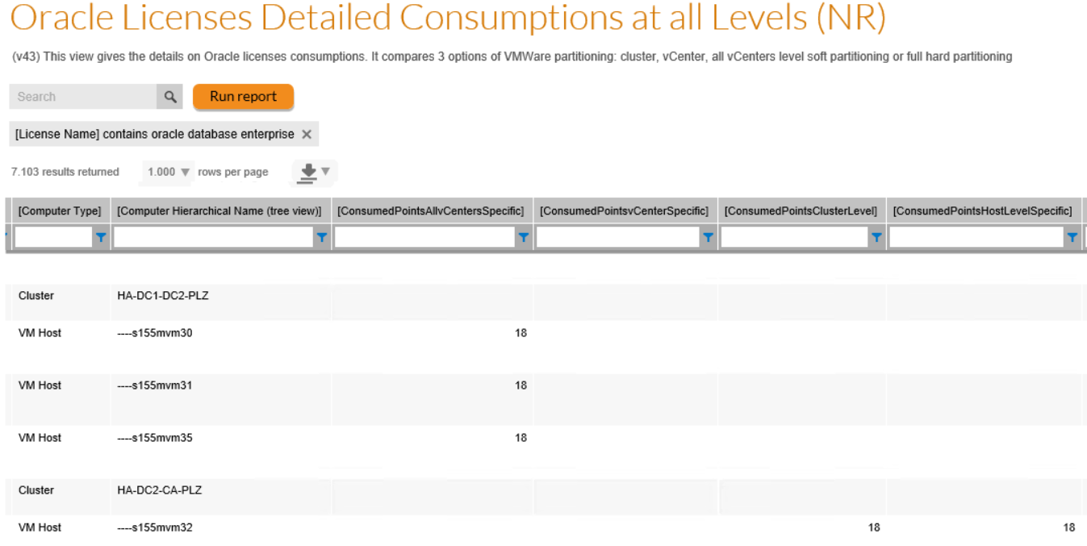

Views creation code (FNMS 2016 and later)

Cluster level

Oracle Licenses Consumptions and Optimizations (NR)

Oracle Licenses Optimizations Summary (NR)
Pivoted view
Flat View

Oracle Options Virtualization Target Architecture (NR)

vCenter level

Oracle Cso and Optim Details at vCenter Level (NR)

Oracle Licenses Consumptions at vCenter Level (NR)

All levels

Oracle Cso and Optim Details at Host, Cluster, vCenter, All vCenters Level (NR)

Oracle Licenses Consumptions Summary at Host, Cluster, vCenter, All vCenters Level (NR)

Appendix 1: list of columns in the detailed consumption report
The list of fields in this view:
- License Name
- Cost per lic right:
  - Will be either the last cost per right o PO lines linked to the license or the override cost of the license
- Computer Hierarchical Name
  - Builds the consuming infrastructure hierarchy required the “Click on this column re-establish hierarchies” colum to be sorted ascending (done by default when launching or resetting the custom view)
- Computer Type
- OS
- Cores
  - Number of Cores. Be careful, in some license consumptions calculations (IBM PVU for instance), the considered number of cores for a VM (LPAR for instance) will be the “Capped number of Cores” or the “Pool number of cores”
- VM installed Cores (for VM Host only)
  - Sum of number of cores of virtual machines installed for the license
- License Points
  - License Consumption for the infrastructure node
- License Cost
  - Consumption * Cost per right
- Waste / Optimization value
  - See list of optimizations in the view. For Oracle processor licenses only. Identifies how much could be saved (or was optimized) considering the soft paprtitioning rule of Oracle: “all ESX servers must be covered if any VM in a cluster is installed with Oracle Database or use Option”
- Rolled Down consumption
  - For each VM, take the portion of the host’s consumption that can be rolled down to the VM level, making a proportion calculation: VM Host Consumption * (# cores of the VM / # cores of all installed VMs). Note that in case of soft partitioning (Oracle Database on vCenter Clusters for instance), the portion of the ESX only is rolled down to the installed VMs.
- Suggested Optimization
  - Licensing recommendations (see above)
- VM Type
- Cluster Name
- vCenterName
- vCenterVersion
  - Only captures for VM Hosts
- Factor
  - Factor as computed by FNMP (for the core points tables)
- Computer Path
  - Cluster/VMHost/VM field that is very practical to make searches of all children of a cluster of instance, across licenses
- Instances covered by the license
  - List of Oracle instances that a license covers. For Oracle Options, only instances with option installed AND used will appear (the ones that actually consume Options licenses)
  - Each instance is followed with the number of active oracle accounts
- Covered installations
  - Alllows to understand on a given consuming node, what version(s) and edition(s) are deployed and consume the license
- Computer Name
- Processor
  - Number of processors
- License Type
- CPU Type
- Allocated
- Exemption Reason
- Server Role
- Server Cost Center
- Server Location
- Root Node
  - The lowest level of any architecture… practical for pivot tables
- Physical Node
  - The level above VMs or the computers (used for reporting)
- Total License Consumption
- Total Cluster Consumption
- Click on this column re establish hierarchies
  - Allows to re-create the hierarchy when sorted ascending (the user can also reset the view)

About Flexera
Flexera is reimagining the way software is bought, sold, managed and secured. We view the software industry as a supply chain, and make the business of buying and selling software more transparent, secure, and effective. Our Monetization and Security solutions help software sellers transform their business models, grow recurring revenues and minimize open source risk. Our Vulnerability and Software Asset Management (SAM) solutions strip waste and unpredictability out of buying applications, helping companies purchase only the software and cloud services they need, manage what they have, and reduce license compliance and security risk. In business for 30+ years, our 1000+ employees are passionate about helping our 80,000+ customers generate millions in ROI every year. Visit us at: www.flexera.com

Flexera
300 Park Blvd., Suite 500
Itasca, IL 60143
USA

Itasca (Global Headquarters):
+1 800-374-4353

United Kingdom (Europe, Middle East Headquarters)
+44 370-871-1111
+44 870-873-6300

Japan (Asia, Pacific Headquarters)
+81 3-4360-8291

Australia
+61 3 9895 2000

www.flexera.com

©2018 Flexera. All rights reserved.
All other brand and product names are trademarks, registered trademarks, or service marks of their respective owners.

©2018 Flexera All rights reserved. All other brand and product names are trademarks, registered trademarks, or service marks of their respective owners.

