Virtual Desktop Infrastructure (VDI) Primer
Flexera Internal Document

What is VDI?

Virtual Desktop Infrastructure (VDI) is the ability to host desktops on remote servers (“thin client”). VDI offers an alternative desktop delivery model. It separates the personal computing environment from the physical machine and provides a “virtualized” desktop that is stored and run on a remote central server. This enables end-users to access their desktop, applications, and data from any device (such as an iPad or any computer). VDI allows users to be mobile and not tied to a single device.

VDI is typically hosted in the datacenter giving IT a centralized mechanism to manage client machines. VDI requires a connection brokering service to connect users to their assigned desktops. Common brokers include Citrix XenDesktop, Oracle VDI, and VMWare View.

The overall VDI infrastructure may include Application Virtualization (App-V) and server virtualization (i.,e, VMWare is hosting the VDI infrastructure)..

Benefits of VDI include:

- Integrated and centralized desktop management
- Enhanced security and compliance
- Anywhere access from connected devices
- Increase Business Continuity
- Decreased Hardware management costs. Clients can be cheaper or older devices.
- Simplified operating system migrations

Challenges of VDI include:

- Determining which end-users are good candidates for VDI.
- Packaging applications for VDI environments
- Insuring end-users have licenses to run all the applications in their VDI slice
- Inventorying VDI slices to find applications

Persistent and Non-Persistent VDI

There are two basic kinds of desktops in VDI: Persistent and Non-Persistent. Persistent VDI means that the user has a stored desktop (one to one) on a server which requires more storage. Non-Persistent VDI means that users share a desktop or single disk image (one to many). As each user logs in, the user gets a clone of the master desktop and then the clone is customized with applications through application virtualization (Microsoft App-V, VMware ThinApp, etc.) or with user environment virtualization (AppSense, RES, etc.). Non-Persistent desktops require Application Virtualization. Non-Persistent desktops also have different licensing implications. Some vendors require licenses for everyone who has access to non-persistent applications.
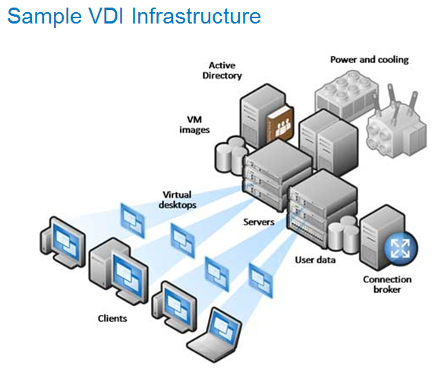

How does Flexera Help with VDI Implementations?

The word “VDI” should be a trigger for the Flexera sales organizations. Flexera helps organizations in all areas of VDI including planning the implementation, packaging applications for VDI, and monitoring license compliance in VDI environments.

Virtual Desktop Assessment

For organizations implementing VDI, it is critical that end-users have a high quality of service with their VDI experience. Some end-users are not good candidates for VDI. Determining which end-users should move to VDI is complex. Factors to consider include:
CPU, RAM, storage, disk IO, graphics, and other resources consumed by applications. End-users with applications that have high resource requirements may not be good candidates for VDI. Flexera’s Virtual Desktop Assessment solution enables organizations to make informed decisions in planning their VDI implementation.

More information on AdminStudio Virtual Desktop Assessment can be found here: http://www.flexerasoftware.com/products/application-packaging/adminstudio-vdi-virtual-desktop-assessment/

Application Virtualization (AdminStudio Virt Pack)

True VDI can only be obtained by leveraging Application Virtualization. AdminStudio’s Virt Pack enables organizations to optimize their VDI infrastructure.
VDI Without Application Virtualization | VDI With Application Virtualization
Number of virtual desktop images needed corresponds to number of unique application user groups. | Enables Non-persistent VDI. Only 1 gold OS image required. Applications deployed in real-time to users upon logon.
Applications in each user group must be tested against one another for conflicts. | Application conflict is eliminated, thus eliminating the need for conflict testing.
Application updates and new application deployments must be managed on each image. | Application updates and new application deployments managed centrally.

License Compliance with VDI (FlexNet Manager, Citrix Adapter)

VDI has significant licensing implications to organizations. In addition to the licensing implications, VDI typically “breaks” the old manual methods of determining license compliance. Customers who have manual processes based on SCCM or other desktop inventory tools will no longer be able to rely on their desktop inventory solution to determine licenses required for their environment.

Vendors have varying and sometimes controversial rules around non-persistent VDI. Some vendors require anyone who can access an application in non-persistent VDI to be licensed (whether they use the application or not). Organizations must track ACLs and ACL usage to accurately count required licenses for all vendors.

Microsoft Licensing with VDI

- Microsoft requires a special license called Virtual Desktop Access (VDA) License for any users who accesses Windows VDI instances
- Customers on Microsoft Software Assurance have Product Use Rights that may include VDA
- Microsoft Enterprise Agreements may include VDA licenses
- All Microsoft Office VDI users need a VDA license and an Office license
- Companion Product Use Rights enable users to access Microsoft applications on a desktop and a VDI instance (similar to secondary use rights – ability to use an application on a local device and VDI/tablet with one license entitlement)

Example 1: John Smith has Microsoft Office installed on his desktop and accesses Office through his VDI desktop
Licenses required: one Microsoft VDA license, one Microsoft Office license if on SA, two Microsoft Office licenses if not on SA

Example 2: John Smith accesses Microsoft Office only through VDI using his tablet device.
Licenses required: one Microsoft VDA license, one Microsoft Office license

Example 3: John Smith accesses four VDI instances/desktops through his tablet.
Licenses required: one Microsoft VDA license for John Smith

Example 4: John Smith accesses six VDI instances/desktops through his tablet
Licenses required: two Microsoft VDA licenses for John Smith as VDA licenses only cover 4 VDIs

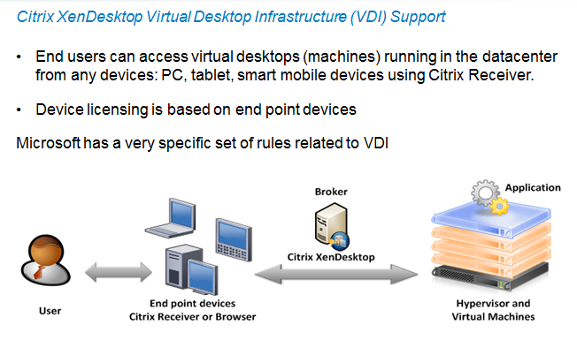

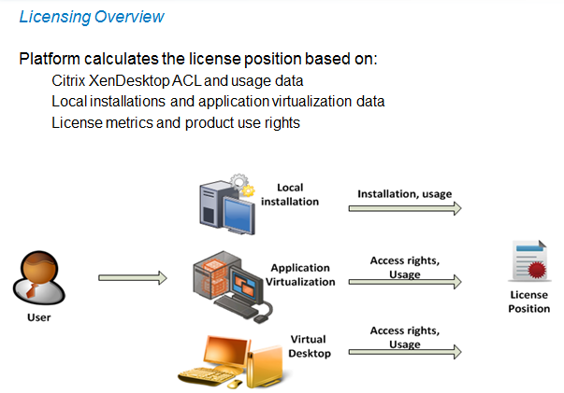

Other Vendor Licensing with VDI

Other vendors such as Adobe, Symantec, etc. typically count an application in VDI as a license.

Technical Details

FlexNet Manager integrates with VDI brokers to determine licenses required. FlexNet Manager is able to determine whether the VDI instance needs a license based on product use rights. FlexNet Manager correctly calculates the number of licenses required based on the applications in a user’s VDI desktop.

Currently, the VDI broker we support is Citrix XenApp Server. Other common brokers such as VMWare Horizons are on the product roadmap.

Citrix Adapter
Supported versions: Citrix XenApp Server 6.0, 6.5, Citrix XenApp EdgeSight 5.4
Requirements:
- XenApp agent on every Citrix server to collect ACL information and parsing streaming profiles
- EdgeSight database access containing application usage data
- Inventory of applications (expected to be contained in ADDM or any other inventory source including SCCM or Flexera Agent)

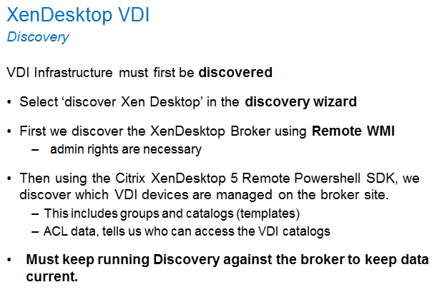

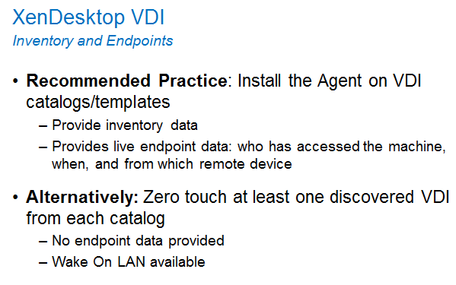

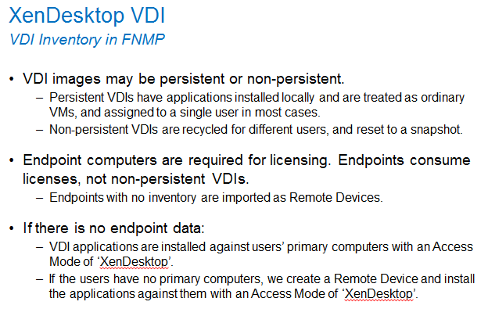

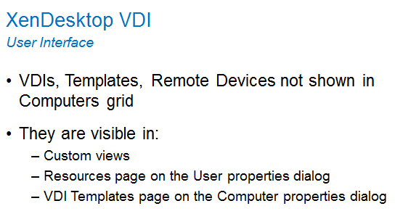

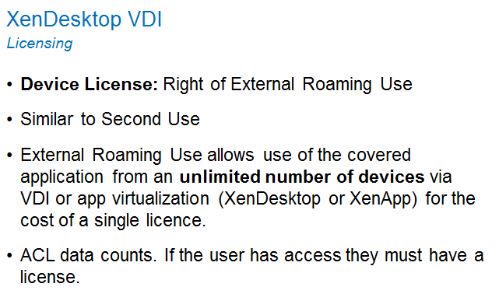

App-V
Requirements: AppV 5.0, SCCM 2012 with Asset Intelligence

Configuration required on AppV:
All applications from prior version of AppV, must be re-sequenced and deployed in AppV 5.0. Version 4.6 does not provide sufficient information needed for software license reconciliation.

Configuration required on SCCM:
During hardware inventory, the following WMI classes must be included for scanning:
- AppvClientApplication
- AppvClientPackage
- AppvClientAsset

Data collected from these classes will be populated into the following SCCM 2012 tables:
- Appv_Client_Application_Data
- Appv_Client_Package_Data
- AppvClientAsset_Data

VDI
Supported configuration: VMWare/vCenter for delivery of non-persistent desktops with Citrix XenDesktop Broker.

Configuration required on VMWare/vCenter: Flexera agent must be installed and configured on the image template used for delivering VDI images.

Configuration required on Citrix XenDesktop Broker server: Flexera agent must be installed and configured on this server. This is required to periodically execute commands to collect access control information on which users are allowed to consume which template.

Remoting is a new feature to Powershell v2.0. It is required by the Citrix Powershell SDK from XenDesktop v5.

The WinRM service must first be installed if it is not already present.
PSRemoting must be enabled.
Add server as trusted hosts.
Allow execution of signed scripts. If the Citrix XenDesktop broker does not have internet access you will need to relax this to unrestricted.

References: KB article Q211361

Document Revision History
June 10, 2014 – Document authored by Cyndi Tackett (based on other presentations by Engineering, Greg Holmes, and the SE team)
June 12, 2014 – Documented edited by Sally Snow

