Go to the Accounts page and for the role, filter on a value of “Portal Admin”. In the example below, this is returning 2 FlexNet Accounts assigned to the role of Analytics Administrator.
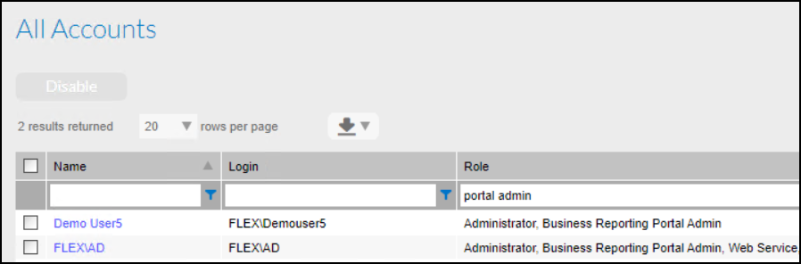

If I go into the properties of the FLEX\AD Account, under Analytics we can see that there is only 1 license available but 2 assignments have been made.
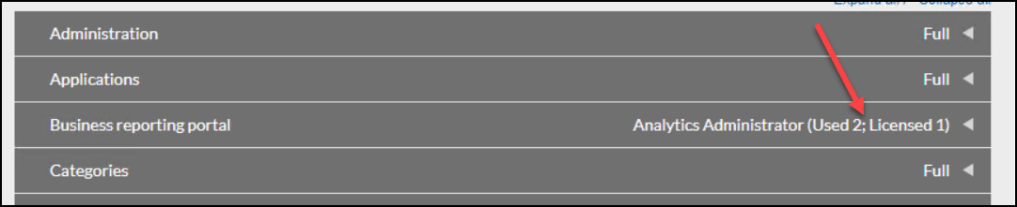

If I attempt to go into Analytics as the FLEX\AD Account, I receive the following error, which is what you are seeing. The key phrase in the error message is “License limits exceeded”.
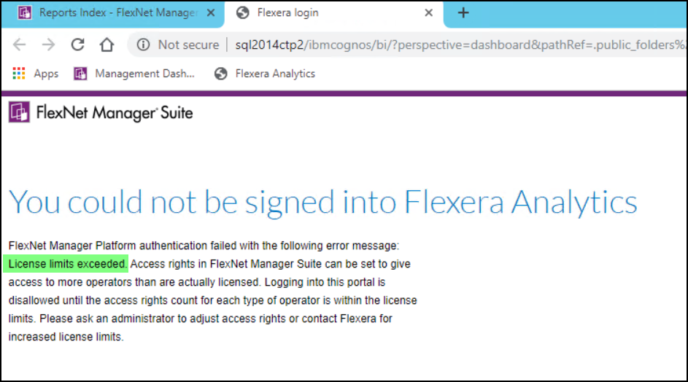

To fix this, remove the assignment of the “Analytics Portal Admin” from the other account, so that only 1 user is assigned to this role. You will then be able to successfully log in.

