HI Andrea,

I have imported below TR’s in to our SCM 7.0 (SCD/SCQ) system, but I am unable to find the role /LICMAN/SATELLITE\*.

E7AK901294 ( RC=4)

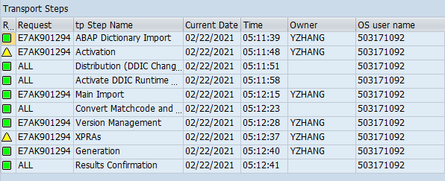

E7AK901242 ( RC=4)

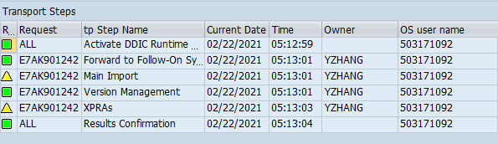

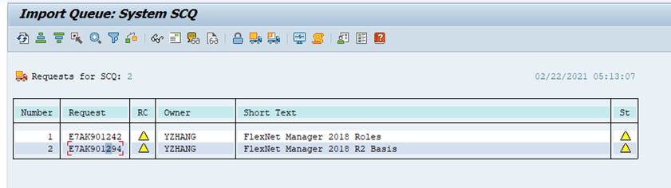

role /LICMAN/SATELLITE\*

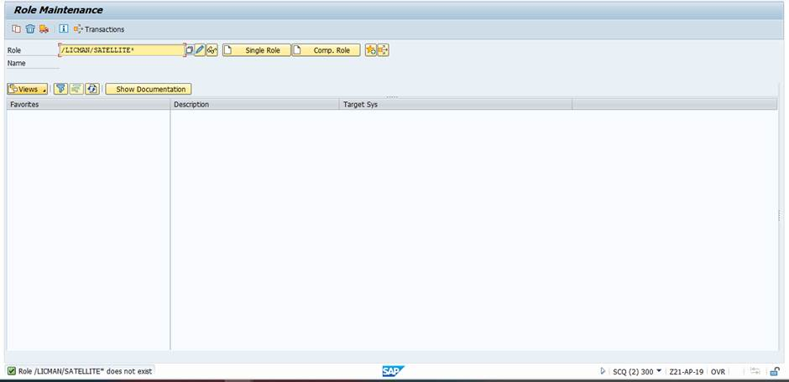

Thanks

Chandu